Receiver (Rx)
What you would need:
- H2A Hydrophone (Fig. 1)
- Laptop or desktop computer with audio jack input
- Audacity software
- Our MATLAB decoder

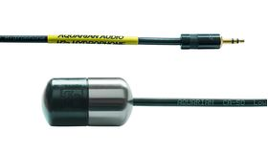
Fig. 1
Link:
https://www.aquarianaudio.com/h2a-hydrophone.html
https://www.audacityteam.org/

MATLAB decoder:
Our decoder identifies the different transmitted frequencies on the downlink using FFT and peak detection. It then down-converts the signals to baseband by multiplying each of them with its respective carrier frequency. The receiver then employs a Butterworth filter on each of the receive channels to isolate the signal of interest and reduce interference from concurrent transmissions. Subsequently, it performs standard packet detection and carrier frequency offset (CFO) correction using the preamble. Finally, it employs a maximum likelihood decoder to decode the FM0 decoded bits.
Code link:

